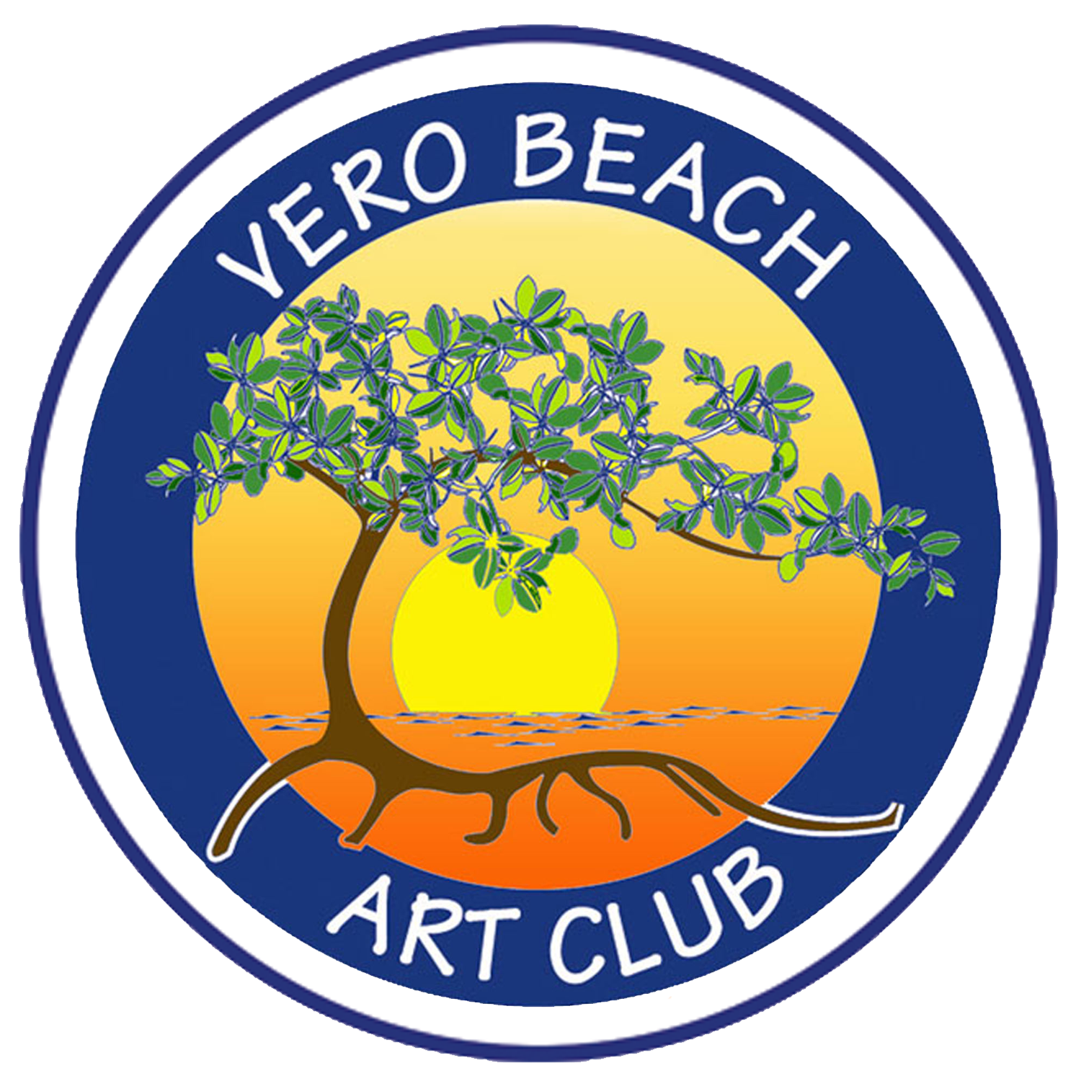

**Art in the Park Application 2024-2025**

VERO BEACH ART CLUB: Application for Art in the Park (AITP)

Season 2024-2025 (updated 6/03/24)

ELIGIBILITY: Must submit your Volunteer Card with your application documenting at least

15

hours of volunteer hours in the twelve months before the current season (October

1

through September 30). If you are a Committee Chair or CoChair for any Art Club

function, just state it on your Volunteer Card.

Must have attended at least three documented VBAC meetings before the first show

participating in.

All applicants, who are NOT "Regular Exhibitors" must submit three (3) photos of your

best art or craft work and one (1) photo of their tent and booth display. Upload photos to

your application.

A $35.00 application fee, which will be used solely to promote, advertise and market AITP

is due with your application submission.

**Image**

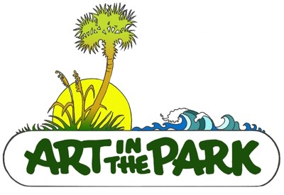

**Exhibitor's Name**

**\***

**First**

**Last**

**Cell Phone:**

**\***

**###**

-

**###**

-

**####**

**Email**

**\***

t

**Website:**

**Member of VBAC Since:**

**\***

**MM**

/

**DD**

/

**YYYY**

**Date Membership Expiration:**

**\***

**MM**

/

**DD**

/

**YYYY**

**Requested Space Location**

**How many volunteer hours do you have from the Last 12 months**

**\***

**Will you be sharing a tent space:**

**\***

**Yes**

**No**

Note: Booth Spaces may be shared by two artists with prior approval of the AITP CoChairs, taking into

account the media balance of the show and the aesthetic congruence of the combined works. Both

artists must be current VBAC members and must be present during the show. Each artist must submit

**If you answered yes to the above question, what artist are you planning on sharing tent**

**space with?**

**First**

**Last**

**Attach your Volunteer Hours Card**

Choose File

No file chosen

**What category is your MAIN medium?: (MUST be more than half of what you display)**

**Check Only One**

**\***

**Collage**

**Fiber**

**Glass**

**Graphics**

**Jewelry**

**Oil and Acrylics**

**Pastels**

**Photography**

**Pottery**

**Watercolor**

**Wood**

**Mixed Media**

**Will you show work from a second category?**

**\***

**Yes**

**No**

**If yes, check one:**

**Collage**

**Fiber**

**Glass**

**Graphics**

**Jewelry**

**Oil and Acrylics**

**Pastels**

**Photography**

**Pottery**

**Watercolor**

**Wood**

**Mixed Media**

**NOT DISPLAYING - NONE**

**Artist's statement or describe work to be displayed. Please include phrases or “taglines”**

**that may be**

**published for AITP promotional work:**

**Artist Agreement and Waiver - VBAC Art in the Park Season 2024-2025**

**I have read and agree to follow the Vero Beach Art Club's Art in the Park Rules and**

**Standards.**

**I agree to indemnify and hold harmless the Vero Beach Art Club and the Show**

**Chairpersons, and the city of Vero Beach from and against any and all demands, claims,**

**suits or liability, to anyone for any injuries sustained by them, whether to their persons,**

**personal assistants or property as a result of coming onto the premises of Humiston**

**Park, (or location of Art in the Park shows) and the adjacent area to work for, or**

**participate in, or attend the Vero Beach Art Club's Art in the Park event.**

**Further, it is understood that each exhibitor is responsible for the collection and payment**

**of their sales tax to the State of Florida.**

**I agree to pay VBAC a 10% commission of all sales made at each show, with a maximum**

**payment of $300 per show. If an exhibitor's sales total $0 to $200, they agree to pay a $20**

**show fee for the day instead of the 10% commission. All sales and commissions must be**

**reported by each Artist on a form provided to you by AITP.**

**Sales Report and Commission Payment are due at 4:00 PM following each show.**

**\***



**Type Your Name as signed above:**

**\***

**Today's Date of Submission**

**\***

**MM**

/

**DD**

/

**YYYY**

**If you are on a desktop computer that does not allow you to touch screen sign please**

**check this box as authority of your signature.**

**Checking this box serves as my signature**

**Art in the Park Season 2024 - 2025 scheduled show dates:**

**Please check the dates you would like to exhibit:**

**\***

**All**

**Oct. 27, 2024**

**Nov. 10, 2024**

**Nov. 24, 2024**

**Dec. 15, 2024**

**Jan. 5, 2025**

**Jan. 19, 2025**

**Feb. 2, 2025**

**Feb 16, 2025**

**Mar. 23, 2025**

**April 6, 2025**

**If A First Time Applicant Please Upload Photos: One Of Your Booth/Tent Display And**

**Three Of Your Best Artwork**

Choose File

No file chosen

**Photo #1 of your art**

Choose File

No file chosen

**Photo #2 of your art**

Choose File

No file chosen

**Photo #3 of your art**

Choose File

No file chosen

YOU MUST ALSO FILL OUT STANDARDS & RULES TO COMPLETE THIS APPLICATION PROCESS.

Total

$0.00

Clear

